**Performance Review System**

Client Server : localhost : 4200

Node Server : localhost : 3000

Run the application :

1. Inside client folder ng build and ng serve – localhost : 4200
2. Inside server folder ng build and npm run start – localhost : 3000

APPlication Start :

Login Page :

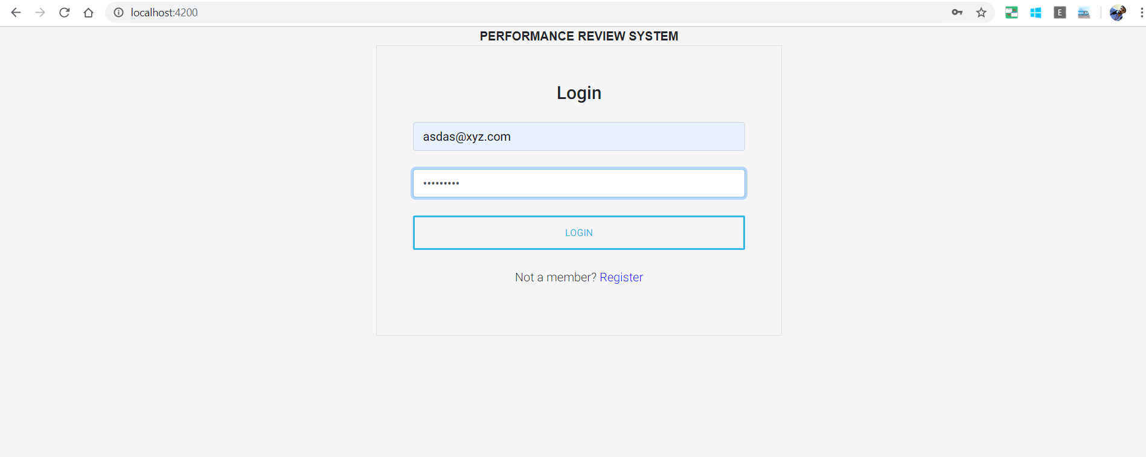

Already not an user Register with mail id

Already an user give mail id and password (mail id not matched I wont go next page)

Registration Page:

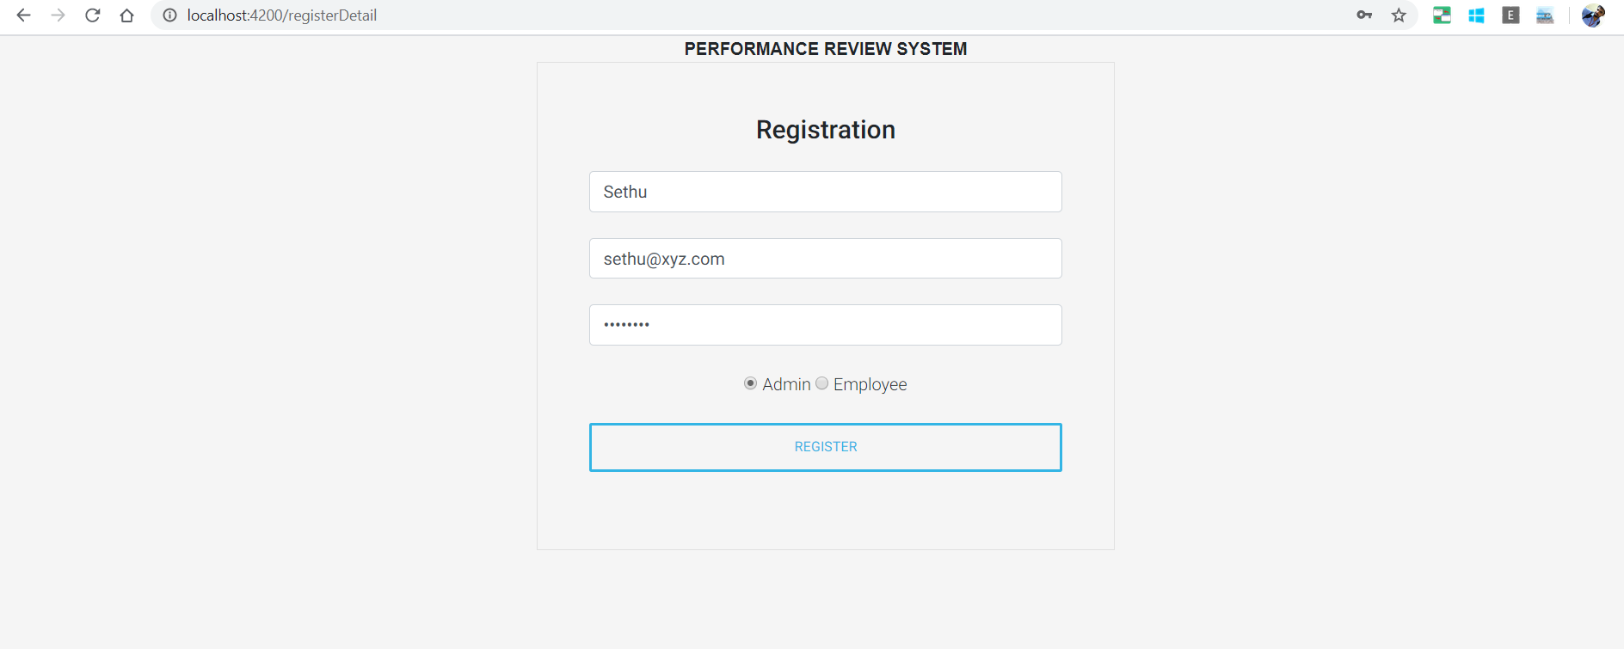

Please give details and mention admin or employee for two different views

When you are **Admin**

1. Can add/edit/delete/view employee and performance review page

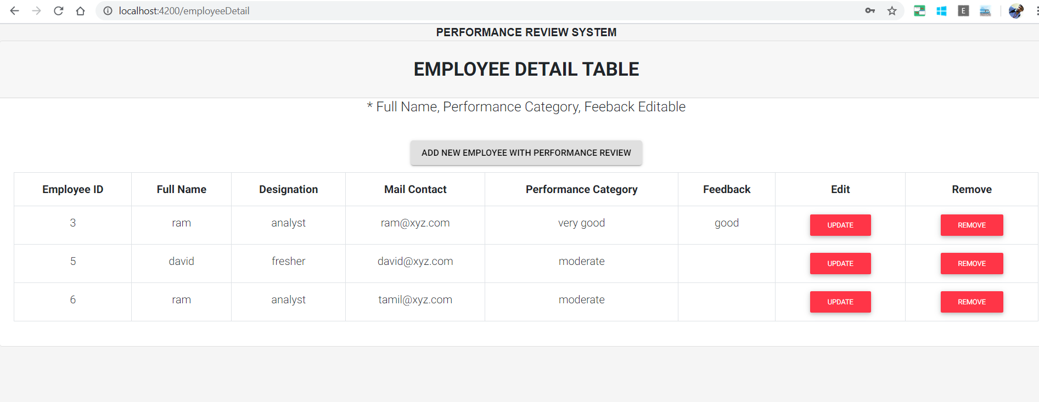

Here you can view employee and performance review details and edit the details while onclick of values and update it

Delete the employees and their performance reviews also

1. Add new employee/Performance review of them

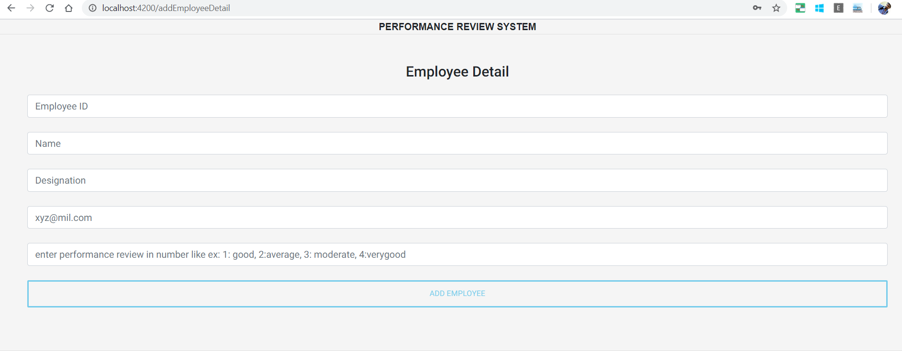

When you are **Employee**

1.List performance review requiring feedback list

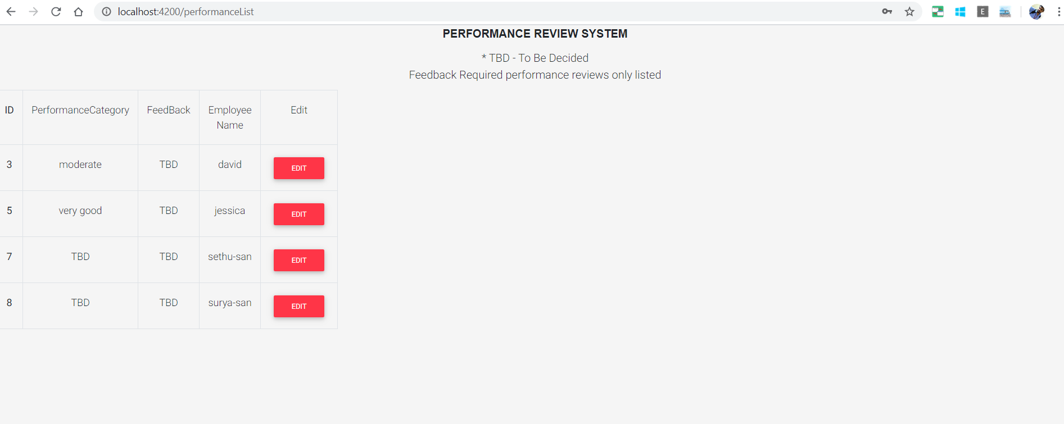

Here listing the required feedback performance review list(TBD – need to give)

When you give edit it will redirect to submit feedback page

1. Submit feedback page

